Athlete Information Sheet

Welcome back to our great sport!
Before we all get back playing, it is important that we understand the guidelines that our Governing Body, England Netball, have put in place and agreed with the Government in order for us to return to the court.

It is important that you take the time to understand these guidelines because training and competition will look very different from the last time we played. Warwickshire County Netball will be working hard to ensure that netball returns to our lives as safely as possible and your cooperation in this is vital!

You will also need to ensure you are affiliated with England Netball through the ENgage system. Once you have read all the following information and are happy to return to training complete the “Opt In” Form.

What is COVID-19?
Coronavirus disease 2019 (COVID-19) is a respiratory illness that affects your lungs and airways. It is caused by a virus called Coronavirus and affected individuals can display a range of symptoms from mild to severe illness and death for confirmed cases. Affected people can also be entirely asymptomatic. Transmission is by respiratory droplets and direct contact.

Personal Risk Assessment
The following information is to make you aware of underlying health conditions that may put you at higher risk of contracting COVID-19. We recommend that you consider the risk to both yourself and your family before returning to any Netball Activity:

People belonging to a BAME Group

People at moderate risk (clinically vulnerable)
- Are 70 or Older
- have a Lung Condition that’s not severe (such as Asthma, COPD, Emphysema or Bronchitis)

have Heart Disease (such as Heart Failure)
- have Diabetes
- have Chronic Kidney Disease
- have Liver Disease (such as Hepatitis)
- have a condition affecting the Brain or Nerves {such as Parkinson’s Disease, Motor Neurone Disease, Multiple Sclerosis or Cerebral Palsy)
- have a condition that means they have a high risk of getting infections
- are taking medicine that can affect the immune system such as low doses of steroids
- are very Obese (a BMI of 40 or above)

People at high risk (clinically extremely vulnerable)
- have had an organ transplant
- are having chemotherapy or antibody treatment for Cancer, including Immunotherapy

are having an intense course of radiotherapy (radical radiotherapy} for Lung Cancer
- are having targeted Cancer treatments that can affect the immune system such as protein kinase inhibitors or PARP inhibitors
- have Blood or Bone Marrow Cancer (such as Leukaemia, Lymphoma or Myeloma)
- have had a Bone Marrow or Stem Cell Transplant in the past 6 months, or are still taking immunosuppressant medicine
- have been told by a doctor you have a severe Lung condition (such as Cystic Fibrosis, Severe Asthma or Severe COPD)
- have a condition that means you have a very high risk of getting infections (such as SCID or Sickle Cell)
- are taking medicine that makes them much more likely to get infections (such as high doses of Steroids or immunosuppressant medicine)
- have a serious heart condition and are pregnant

OPT In Process – NO PRESSURE
There is no pressure from anyone within the netball family to return if they are uncomfortable with the risks due to their own personal situation, or that of a close family member that they live with.

When you feel comfortable, you will be welcomed back to training but in the meantime, if you choose not to you will very much still remain a member of our netball family.
Please complete the “Opt In” form and return

Wellbeing
This last year has clearly been a challenging time for us all. We understand that each of us will have had very different experiences over that period. We want you to know that we are here for you and that we are happy to chat through any concerns or issues you may have and that, if we cannot help you ourselves, we will be able to advise on where you can obtain support or information to help with your wellbeing.

- BEFORE NETBALL

Pre-Activity Health Screening
All players should check themselves or anyone in their household for COVID-19 symptoms before leaving for netball activity. If you or anyone else in your household has symptoms, you should not attend netball activity.

Symptom | YES | NO
A fever?
A new, continuous cough?
Any loss or change to your sense of taste or smell?
Has any member of your household or someone that you have been in contact with reported any of the above symptoms in the last 14 days?
Has any member of your household or someone that you have been in contact with tested positive for COVID-19 in the last 14 days?
Have you been notified by the NHS Test and Trace system that you are a close contact of someone with known COVID-19 infection in the last 14 days?

Kit, Sanitisation and Equipment
Athletes should come ready to train. Changing facilities should not be used. Hands and any personal equipment or items should be sanitised before leaving for netball. Any personal items such as water bottles, ball, S & C Equipment should be clearly marked with your name.

Travel to Venues
The Government are continuing to advise on the best way to travel. If you are unable to travel independently or must travel with those outside of your support bubble, check the latest Government guidance.

- DURING NETBALL

On Arrival
- All athletes should follow any venue specific arrival protocols and traffic flow systems.
- Upon entering the venue, all attendees should remain 2m apart at all times from those outside of their social bubble and wear a cloth mask.
- When registering, players must maintain social distancing and wear a cloth mask.
- All players are required to register on arrival with their Head Coach. This will include further health screening for COVID-19 symptoms.

Sanitisation and Equipment
All players are required to sanitise their hands every 15 minutes during activity.

All players should use their own netball. Where your organiser provides balls, only sanitised balls should be used and it is required that they are sanitised every 15 minutes during activity.

Bibs should not be shared. Warwickshire Netball will let you know what arrangements are being made where there are not enough sets available. Water bottles and whistles should also not be shared.

Social Distancing
Wherever possible, social distancing will be incorporated into warm up activities and small sided games.

The following must not take place during any training sessions or netball matches:
- Nail checks should take place from 2m
- There should be no pre-match huddle – players should remain socially distanced for any pre-match team talk
- No pre-match or pre quarter ‘hands in’
- No shouting or cheering
- No quarter or half time huddles
- No high fiving
- No post-match hug circles or handshakes
- Any post-match paperwork should be shared digitally (this could be e mail or photograph)
- No post-match team teas
- Team selfies must be socially distanced

- AFTER NETBALL
Social Distancing
- At the end of activity all players should leave the court straight away and leave the venue promptly.
- All players should follow any venue specific arrival protocols and traffic flow systems.
- If you are U18, a safe collection procedure and point should be pre-organised.

Hygiene and Sanitisation
- Changing facilities should not be used and will not be available for players wishing to shower.
- All athletes should sanitise their hands on leaving the venue.
- Any personal equipment must be sanitised after every activity.

Test and Trace
Any attendee who develops COVID-19 symptoms up to 48 hours after any netball activity must report to NHS Test and Trace and notify the COVID-19 Officer if the test is positive.

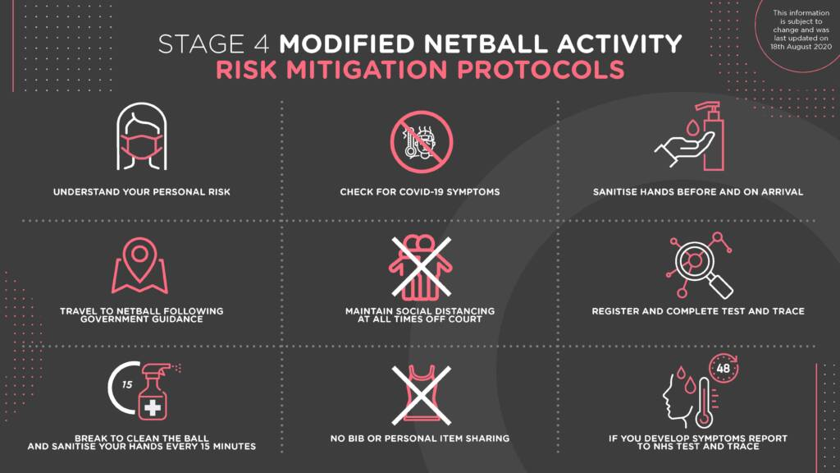

- THE GAME
The Game has been modified to account for the Government Guidelines, having regard for Social Distancing.
The following rule modifications must now be adhered to at all community levels of the game:
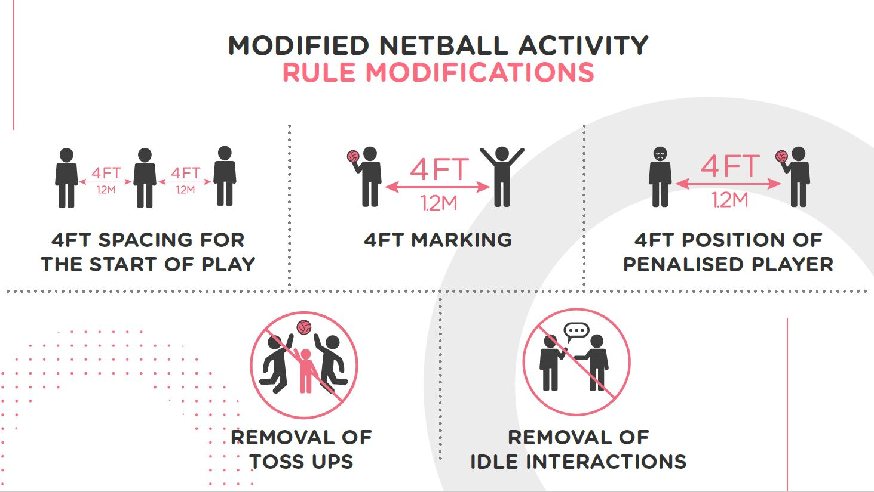
- 4ft spacing for the start of play – GS and GK are required to start inside their respective goal circles, GA, GD, WA and WD on the transverse line and the centres in the centre third. The modification requires all players to position themselves a minimum of 4ft away from their opposing players and teammates at the start of play. This will be managed by umpires at the start of play.
- 4ft marking – the defending distance has been increased from 3ft to 4ft. Particular attention must be paid in the goal circle when defending or waiting for a rebound under the goal post. This will be blown as distance.
- 4ft position of penalised player – penalised players for major infringements are required to position beside the player they infringed but from a distance of 4ft away. This will be managed by umpires when an infringement occurs.
- Removal of Toss Ups – No toss ups are permitted, the team who had the ball directly before the action that caused the toss up to be awarded will retain possession. The umpire will briefly hold time, instruct the ball to be returned to the relevant team and play will be restarted on the umpire’s whistle.
- Removal of idle interactions – Players not engaged in play or who are stood still are required to be positioned 4ft away from another player. This frequently happens on the circle edge, on the transverse line, whilst walking back to centre pass and returning to the team bench at the end of a quarter. Managed by umpires and supported by players and coaches.
- FINALLY
Have Fun! And Welcome back, we couldn’t be happier that we can now #RiseAgain!

If you have any questions or concerns, please do not hesitate to contact your COVID-19 Officer:
Lesley Blair
COVID-19 Officer
Performance Lead
Warwickshire County Netball
E: netballwarwickshire@gmail.com
M: 07808 079236

WARWICKSHIRE NETBALL COVID-19 HEALTH DECLARATION
The purpose of the questionnaire is to screen for possible symptoms of Covid-19 infection.
The aim is to promote and maintain the health and safety of all our Netball family. Please help us by answering the questions below honestly and accurately BEFORE you set out for your training.
If you answer ‘YES’ to any of the questions below you MUST NOT attend training and instead notify the Club Covid Officer and follow Public Health England Advice on self-isolation and testing
Today or in the last 7 days have you had:

Symptoms | Yes | No
A Fever?
A new, continuous cough?
Any loss or change to your sense of taste or smell?
Has any member of your household or someone that you have been in contact with reported any of the above symptoms in the last 14 days?
Has any member of your household or someone that you have been in contact with tested positive for Covid-19 in the last 14 days?
Have you been notified by the NHS test & trace system that you are a close contact of someone with known Covid-19 infection in the last 14 days?

If you answer NO to all of the questions above you may travel to the venue, where a verbal check will be conducted to confirm whether the answers are still NO and if so, you will be able to enter the venue.

Parents / Guardians should wait at drop-off until the athlete has been admitted to the session before departing

WARWICKSHIRE NETBALL OPT – IN STATEMENT

I have been made aware of the risks associated with netball activity and COVID-19 and understand this. I also understand there are some people who are of higher risk of contracting COVID-19.
I am comfortable with the information I have been provided and opt in to participate in netball. I also confirm I understand the requirements and steps I need to take to help prevent the spread of COVID-19 through netball and agree to take these steps.

Signed Date

Name

